DOCAYA
Enterprise Electronic Document Management System
Technical Architecture Document
Solution Architecture · Application Architecture · Security · Data · Integration · Operations

Document type | Technical Architecture Document (TAD)
Platform | Microsoft Azure · Microsoft 365 · SharePoint Online · Microsoft Entra ID · National SSO
Architecture style | Cloud-native, event-driven, staging-first, zero-trust
Version | 1.0
Status | Draft for Review
Classification | OFFICIAL – Internal
Date | September 2026

Document Control
Version History
Version | Date | Summary of change
0.1 | Aug 2026 | Initial architecture skeleton and principles
0.9 | Sep 2026 | Solution and application architecture, security and data views
1.0 | Sep 2026 | Complete technical baseline with all architecture aspects and diagrams
Reviewers & Approvals
Review area | Responsibility | Decision
Solution Architecture | Architecture fitness, integration, operability | Pending
Security & Identity | Zero-trust, identity, secrets, network controls | Pending
Data & Compliance | Classification, retention, residency, audit | Pending
Platform & Operations | Reliability, observability, deployment | Pending
Programme Governance | Scope, risk, investment | Pending
Related Artifacts
- Functional & Business Design Specification (lifecycle, modules, requirements).
- Solution Architecture diagram (connected component & data-flow view).
- Application Architecture diagram (layered component & module view).
- Infrastructure-as-Code templates and CI/CD pipeline definitions.

Table of Contents

1. Introduction
1.1 Purpose
This Technical Architecture Document (TAD) defines the end-to-end technical architecture of the Docaya Electronic Document Management System (EDMS). It is the authoritative engineering reference that translates the functional and business requirements into a concrete, cloud-native solution built entirely on Microsoft Azure, Microsoft 365, SharePoint Online and Microsoft Entra ID. It describes the solution architecture, the application (component) architecture, and the supporting data, integration, security, infrastructure and operations views.
1.2 Scope
In scope | Out of scope
Logical and physical architecture; application components and modules; data model and stores; integration with SharePoint and AI services; identity and access; security, network and encryption; deployment, observability and operations; non-functional design; and architecture decisions. | Detailed low-level class design and source code; project plans and commercials; organisation-specific naming and data; and migration of pre-existing content, which is handled by a separate workstream.
1.3 Intended Audience
- Solution & technical architects — to validate architecture fitness and evolve the design.
- Engineering teams — to implement components against a shared blueprint.
- Security, identity and compliance reviewers — to assess controls and residency.
- Platform and operations teams — to provision, deploy, monitor and run the system.
1.4 Definitions & Acronyms
Term | Meaning
EDMS | Electronic Document Management System
Staging Zone | Controlled holding area (Blob or SharePoint staging) before approval
Promotion | Moving an approved document from staging into the live SharePoint library
SoR | System of Record (SharePoint Online for content; Azure SQL for metadata/audit)
RAG | Retrieval-Augmented Generation (grounded AI search)
RBAC / ABAC | Role- / Attribute-Based Access Control
BFF | Backend-for-Frontend
OBO | On-Behalf-Of OAuth flow
MI | Managed Identity (secretless workload identity)
APIM | Azure API Management
RPO / RTO | Recovery Point / Time Objective
1.5 Requirement Conventions
Normative statements use RFC-2119 keywords: MUST, SHOULD and MAY. Architectural decisions that constrain implementation are captured as Architecture Decision Records (ADRs) in Section 19.

2. Architecture Goals & Principles
2.1 Architecture Goals
# | Goal | Rationale
G1 | Governed publishing | No content becomes a record until registered, classified and approved.
G2 | Single source of truth | Content in SharePoint Online; metadata, workflow and audit in Azure SQL.
G3 | Secure by default | Zero-trust, least privilege, everything authenticated and audited.
G4 | Cloud-native & elastic | Managed PaaS services that scale horizontally and fail over cleanly.
G5 | Event-driven & decoupled | Long-running and side-effecting work is asynchronous and idempotent.
G6 | Intelligent retrieval | Permission-trimmed hybrid search and grounded AI answers over approved content.
G7 | Operable & observable | End-to-end tracing, actionable alerts and repeatable deployments.
2.2 Guiding Principles
Principle | Design implication
SharePoint is the content system of record | Published binaries and native versions live in governed libraries; no lock-in.
Staging-first | Incomplete or unapproved content is isolated in a controlled staging zone.
Configuration over code | Document types, routing, retention and notifications are managed, not hard-coded.
Least privilege everywhere | Human and workload identities receive only the access they need, at resource scope.
Idempotent side effects | Promotion, indexing and notifications tolerate retries without duplication.
Defence in depth | Controls are layered across identity, network, application and data.
Human-accountable automation | AI assists retrieval; humans decide; every action is attributable.
2.3 Architecturally Significant Quality Attributes
Attribute | Target / approach
Security | Zero-trust, deny-by-default RBAC+ABAC, private networking, encryption, immutable audit.
Availability | 99.9% baseline via zone-redundant PaaS and health-based routing.
Performance | p95 page load < 1.5s; search p95 < 400 ms.
Scalability | Stateless services scale horizontally; async workers absorb bursts.
Reliability | Idempotent operations; retries with backoff; dead-letter handling.
Recoverability | RPO ≤ 5 min, RTO ≤ 1 hr; geo-redundant backups.
Maintainability | Modular services, clean adapters, IaC and automated pipelines.
Accessibility | WCAG 2.2 AA; bilingual and right-to-left capable presentation.
2.4 Constraints & Assumptions
- The platform is delivered exclusively with native Azure and Microsoft 365 services; no third-party platform is required.
- A licensed SharePoint Online tenant and a federated national single-sign-on provider are available.
- All data resides within the approved sovereign Azure region(s) to meet residency requirements.
- Identity is centralised: user access is governed inside the application, while content operations use a governed service identity.

3. Architecture Approach & Views
The architecture is described through complementary views so that each stakeholder can reason about the parts that matter to them. Together they provide a complete and consistent picture of the system.
View | Question it answers | Where in this document
Solution / physical | Which services run and how do they connect? | Section 4
Application / logical | How is the software organised into components? | Section 5
Process / runtime | How does work flow end to end? | Section 6
Data | What is stored, where, and under what rules? | Section 7
Integration | How do systems and identities interoperate? | Section 8
Security | How is the system protected? | Section 9
Infrastructure / deployment | How is it provisioned and released? | Section 10
Operations | How is it observed and run? | Section 11
Reading the two core diagrams Section 4 presents the Solution Architecture — the connected view of Azure and Microsoft 365 building blocks and the data flows between them. Section 5 presents the Application Architecture — the internal, layered composition of the software. Both are shown full-size on the following landscape pages and then described in detail.

4. Solution Architecture
The solution architecture organises the platform into eight cooperating zones — users and channels, identity and single sign-on, the security edge, application services, asynchronous orchestration and messaging, data and content, the Microsoft 365 system of record, and the cross-cutting platform. The diagram overleaf shows every component and the integration paths between them, including the staging-first promotion path and the post-publish retrieval-augmented indexing path. A numbered one-to-ten sequence traces a document from sign-in to searchable record.
The figure is presented full-width on the next (landscape) page for legibility; the layers are then described in detail in Sections 4.1–4.8.

Figure 1 — Connected Solution Architecture
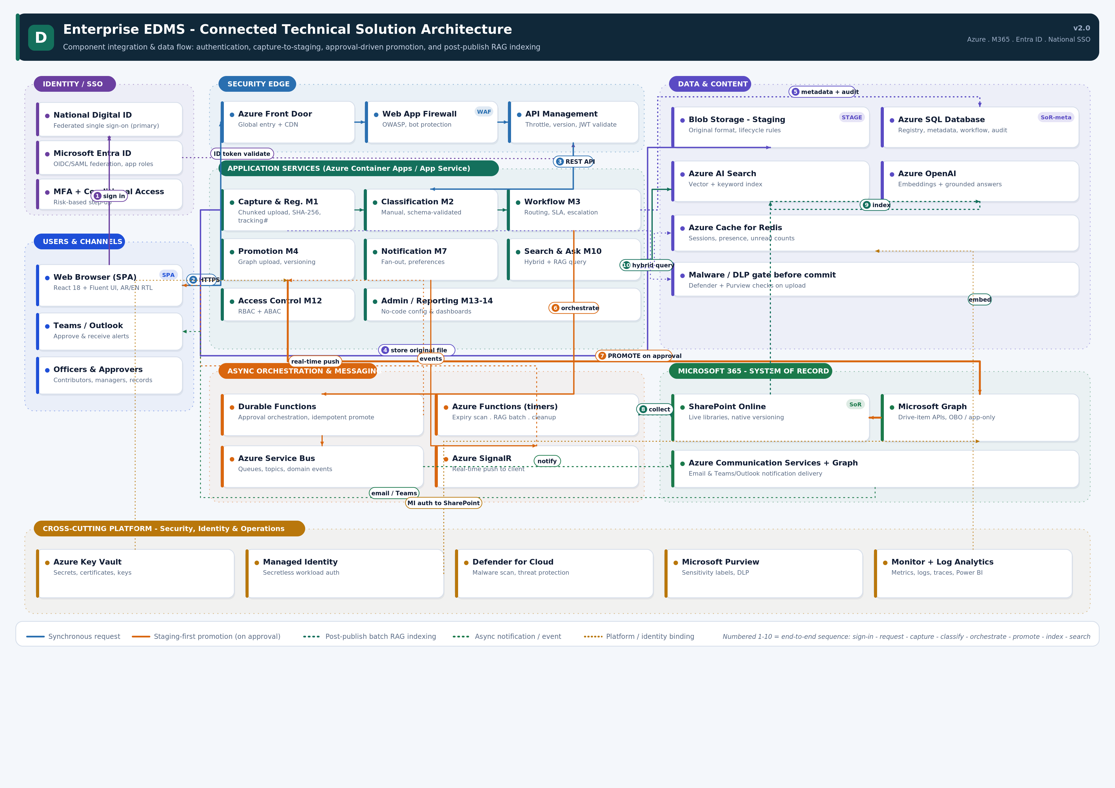
Figure 1 — Solution architecture: Azure & Microsoft 365 building blocks, integration paths, staging-first promotion (orange) and post-publish RAG indexing (teal).

4.1 Users & Channels
Contributors, approvers, records officers and administrators interact through a single-page web application, with Microsoft Teams and Outlook as secondary channels for approvals and notifications. The client is a modern, accessible experience that is bilingual and right-to-left capable.
Component | Responsibility
Web Browser (SPA) | Primary experience for capture, classification, approvals, search and administration.
Teams / Outlook | Approve documents and receive alerts within existing collaboration tools.
4.2 Identity & Single Sign-On
Authentication is federated: a national digital identity provider is the primary sign-on, federated to Microsoft Entra ID which issues application tokens, enforces multi-factor authentication and conditional access, and drives step-up authentication for sensitive actions.
Component | Responsibility
National Digital ID | Primary, standards-based single sign-on for all users.
Microsoft Entra ID | OIDC/SAML federation, application roles, token issuance.
MFA + Conditional Access | Risk-based and step-up authentication policies.
4.3 Security Edge
All ingress passes through a hardened edge. Azure Front Door provides global entry and content delivery, a Web Application Firewall blocks common threats and bots, and Azure API Management enforces throttling, versioning and JSON Web Token validation before any request reaches a service.
Component | Responsibility
Azure Front Door | Global entry point, routing and CDN.
Web Application Firewall | OWASP protection and bot mitigation.
Azure API Management | Rate limiting, versioning, token validation, policy enforcement.
4.4 Application Services
The application tier hosts the domain modules as independently deployable services on Azure Container Apps or App Service. Each service owns a bounded context — capture and registration, classification, workflow and approval, promotion, notification, search, access control, and administration and reporting — and emits domain events for loose coupling and audit.
4.5 Asynchronous Orchestration & Messaging
Long-running and side-effecting work is asynchronous. Durable Functions orchestrate the approval and idempotent promotion process; Azure Service Bus carries queues, topics and domain events; timer-triggered Azure Functions run the expiry scan, the batch indexing job and staging cleanup; and Azure SignalR pushes real-time updates to the client.
Component | Responsibility
Durable Functions | Stateful orchestration of approval and promotion; idempotent by design.
Azure Service Bus | Reliable queues, topics and event distribution.
Azure Functions (timers) | Expiry reminders, batch RAG indexing, staging lifecycle cleanup.
Azure SignalR | Real-time notification push to connected clients.
4.6 Data & Content
The data zone separates transient staging from durable stores. Azure Blob Storage holds the original file during capture, classification and approval; Azure SQL Database is the authoritative registry for metadata, workflow state and the hash-chained audit; Azure AI Search holds the vector and keyword index; Azure OpenAI provides embeddings and grounded answers; and Azure Cache for Redis serves sessions, presence and unread counts. A malware and data-loss-prevention gate validates every upload before it can proceed.
Component | Responsibility
Blob Storage (Staging) | Holds the original file in its native format with lifecycle rules.
Azure SQL Database | Registry, metadata, workflow state and tamper-evident audit.
Azure AI Search | Hybrid vector + keyword index over approved content.
Azure OpenAI | Embeddings and grounded, cited answers for the assistant.
Azure Cache for Redis | Sessions, presence and unread notification counts.
Content-safety gate | Malware scan and DLP/classification checks before commit.
4.7 Microsoft 365 — System of Record
Approved content lives in SharePoint Online, which provides governed libraries and native versioning. Microsoft Graph is the integration surface for drive-item operations, performed under a governed workload identity. Azure Communication Services and Graph deliver email and Teams/Outlook notifications.
Component | Responsibility
SharePoint Online | Live libraries, native versioning; content system of record.
Microsoft Graph | Drive-item APIs for promotion and retrieval; OBO / application permissions.
Communication Services + Graph | Email and Teams/Outlook notification delivery.
4.8 Cross-Cutting Platform
Platform services apply to every zone: Azure Key Vault for secrets, certificates and keys; Managed Identity for secretless workload authentication; Microsoft Defender for Cloud for threat protection and upload malware scanning; Microsoft Purview for sensitivity labelling and data-loss prevention; and Azure Monitor with Log Analytics (and Power BI) for metrics, logs, traces and dashboards.
Staging-first & RAG paths The orange path shows that a document is promoted into the correct SharePoint library only on approval, in its original format. The teal path shows that retrieval-augmented indexing runs as a batch over approved, published content — never during capture or classification.

5. Application Architecture
The application architecture describes how the software itself is composed. It follows a clean, layered structure with clear dependency direction from top to bottom: a presentation tier, an API gateway and backend-for-frontend, the application (domain) services, a domain model and business-logic layer, integration and anti-corruption adapters, and a data-access and persistence layer. Cross-cutting concerns apply to every layer, and asynchronous workers handle orchestration and scheduled processing.
The component diagram is presented full-width on the next (landscape) page and then described tier by tier in Sections 5.1–5.7.

Figure 2 — Detailed Application Architecture
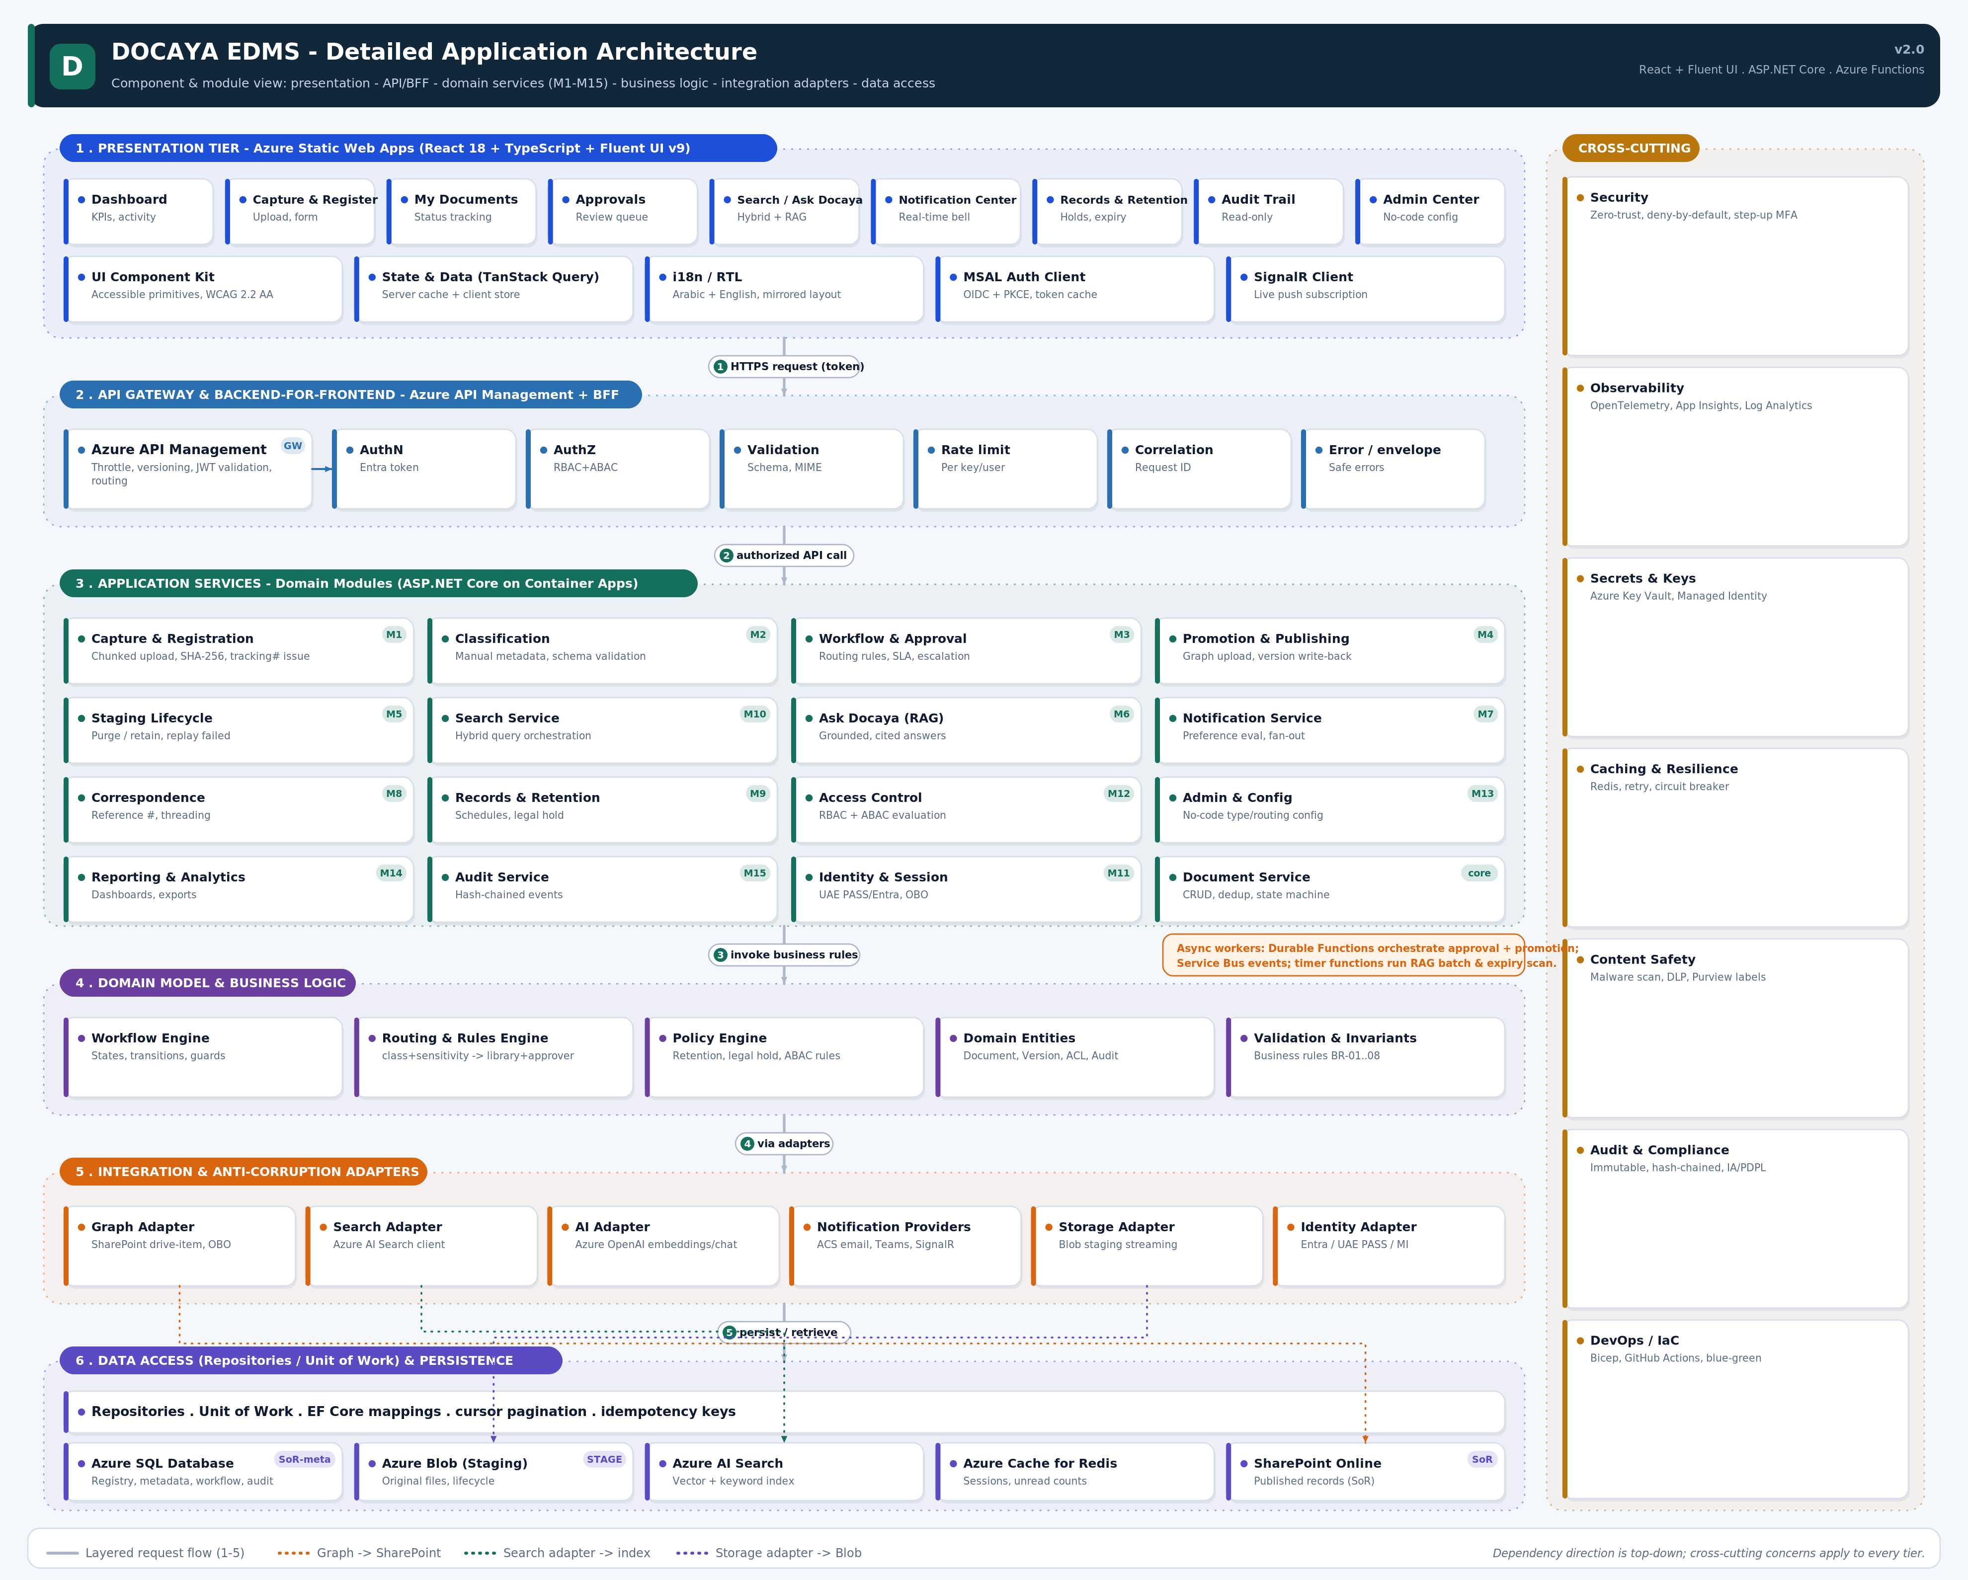
Figure 2 — Application architecture: presentation, API/BFF, application services (M1–M15), domain logic, integration adapters, data access, and cross-cutting concerns.

5.1 Presentation Tier
The presentation tier is a React 18 and TypeScript single-page application built with Fluent UI and hosted on Azure Static Web Apps. It is composed of nine feature modules and five foundation blocks.
Group | Components
Feature modules | Dashboard · Capture & Register · My Documents · Approvals · Search / Ask · Notification Center · Records & Retention · Audit Trail · Admin Center
Foundation | Accessible UI component kit · State & data (server cache + client store) · i18n / RTL · Auth client (OIDC + PKCE) · Real-time client (SignalR)
5.2 API Gateway & Backend-for-Frontend
A backend-for-frontend behind Azure API Management aggregates reads, shapes responses for the client, and hosts the request-processing pipeline. Every request passes through authentication, authorization (RBAC + ABAC), input validation, rate limiting, correlation-ID assignment and a normalised error envelope.
Pipeline stage | Function
Authentication | Validate the Entra-issued bearer token.
Authorization | Enforce deny-by-default RBAC + ABAC for the operation and object.
Validation | Validate body, schema, MIME type and identifiers.
Rate limiting | Protect services per key/user.
Correlation | Attach an end-to-end request ID.
Error handling | Return safe, structured error envelopes without leaking internals.
5.3 Application Services (Domain Modules)
The domain modules implement the business capabilities. Each is a cohesive service with a single responsibility, communicating synchronously via the BFF and asynchronously via events.
Module | Responsibility
M1 Capture & Registration | Chunked upload, SHA-256 hashing, tracking-number issue, registry creation.
M2 Classification | Manual, schema-validated metadata capture.
M3 Workflow & Approval | Routing rules, SLA timers, escalation, decision handling.
M4 Promotion & Publishing | Graph upload of the original file, version write-back.
M5 Staging Lifecycle | Purge or retain staging, replay failed promotions.
M6 Ask (RAG) | Grounded, cited answers over permitted content.
M7 Notification | Preference evaluation and multi-channel fan-out.
M8 Correspondence | Reference numbers, threading and action tracking.
M9 Records & Retention | Retention schedules, disposition and legal hold.
M10 Search | Hybrid keyword + semantic query orchestration.
M11 Identity & Session | Federated sign-on, OBO and session management.
M12 Access Control | RBAC + ABAC effective-permission evaluation.
M13/M14 Admin & Reporting | No-code configuration, dashboards and exports.
M15 Audit | Hash-chained, tamper-evident event recording.
Document Service (core) | CRUD, deduplication and the document state machine.
5.4 Domain Model & Business Logic
Business rules are centralised in a domain layer independent of infrastructure. It contains the workflow engine (states, transitions and guards), the routing and rules engine (mapping class and sensitivity to library and approvers), the policy engine (retention, legal hold and ABAC rules), the domain entities (document, version, ACL, audit), and the invariants that enforce the platform's business rules.
5.5 Integration & Anti-Corruption Adapters
External systems are reached only through adapters that isolate the domain from provider-specific detail. This keeps the core clean and makes providers replaceable.
Adapter | Encapsulates
Graph Adapter | SharePoint drive-item operations via Microsoft Graph (OBO / app-only).
Search Adapter | Azure AI Search indexing and query.
AI Adapter | Azure OpenAI embeddings and chat completions.
Notification Providers | Communication Services email, Teams and SignalR.
Storage Adapter | Streaming to and from Blob staging.
Identity Adapter | Entra, national SSO and Managed Identity token acquisition.
5.6 Data Access & Persistence
A repository and unit-of-work layer with EF Core mappings mediates all persistence, providing cursor pagination and idempotency keys. It fronts Azure SQL (registry, metadata, workflow, audit), Blob staging (original files), Azure AI Search (index), Redis (cache) and SharePoint Online (published records).
5.7 Cross-Cutting Concerns & Async Workers
Security, observability, secrets management, caching and resilience, content safety, audit and DevOps apply across all layers. Asynchronous workers — Durable Functions, Service Bus consumers and timer functions — orchestrate approval and promotion, distribute events, and run the batch indexing and expiry jobs, all with idempotent, retry-safe semantics.

6. Process & Runtime View — End-to-End Lifecycle
The platform enforces a controlled capture → classify → approve → promote pipeline, followed by batch indexing and continuous access governance. The table below is the authoritative runtime sequence.
# | Stage | Runtime behaviour | Status
1 | Capture / Register | Original file streamed to Blob staging; SHA-256 computed; tracking number issued; registry row created in Azure SQL. | PendingRegistration
2 | Classify | Contributor selects class, sensitivity, department and approval flow; metadata validated and persisted. | Classified
3 | Submit | Routing rules resolve target library and approver(s); item enqueued to the approver. | PendingApproval
4 | Notify | Events raised to the Notification Service; in-app, email and Teams alerts delivered. | (no change)
5 | Decide | Approver approves, or rejects with mandatory comments returning the item to the initiator. | Approved / Returned
6 | Promote | Durable Functions call Graph to upload the original file to the correct library; item ID, URL and version 1.0 written back. | Published
7 | Cleanup | Staging reconciled (purge or retain); contributor notified of publication. | Reconciled
8 | Index (RAG) | Batch job chunks and embeds published content and metadata into Azure AI Search. | Indexed
9 | Access & Govern | Federated SSO; RBAC+ABAC evaluation; audit; retention and legal hold applied. | Continuous
6.1 Consistency & Idempotency
- Azure SQL is authoritative for metadata, workflow state and audit; SharePoint is authoritative for content.
- Promotion carries an idempotency key so a retry can never create a duplicate SharePoint item.
- SharePoint item ID, URL and version are committed only after a successful upload; failures remain recoverable in staging.
- Indexing is asynchronous, permission-aware and fully re-runnable.

7. Data Architecture
7.1 Storage Strategy
Store | Purpose | Notes
Azure SQL Database | Registry, metadata, workflow state, audit | Authoritative for all structured data; hash-chained audit.
Azure Blob (Staging) | Original files pre-approval | Native format preserved; lifecycle rules for cleanup.
SharePoint Online | Published records | Content system of record with native versioning.
Azure AI Search | Vector + keyword index | Built from approved content; permission-trimming keys.
Azure Cache for Redis | Sessions, presence, counts | Low-latency ephemeral state.
Archive tier / repository | Cold records | Retention-driven archival with registry linkage.
7.2 Core Entities
Entity | Purpose | Key fields
Document | Central registry & lifecycle | TrackingNumber, Status, Class, Sensitivity, ExpiryDate, SharePointItemId
Version | Immutable version reference | VersionLabel, SharePoint version, CreatedAt
AccessEntry | ABAC / scoping | PrincipalId, PrincipalType, Permission
WorkflowInstance | Approval state & history | Stage, AssignedTo, Decision, ActedAt
Notification | Durable notification history | UserId, Type, Channel, ReadAt
AuditEvent | Tamper-evident audit | ActorId, Action, RequestId, PrevHash, Hash
RetentionPolicy | Lifecycle rules | Trigger, Duration, Disposition
7.3 Data Classification & Handling
- Every document carries a sensitivity marking (Public, Internal, Confidential, Secret) that drives access and routing.
- Sensitivity labels and data-loss-prevention policies are applied through Microsoft Purview.
- Personal data is minimised, access-controlled and processed lawfully in line with applicable data-protection law.
7.4 Retention, Legal Hold & Residency
- Time- or event-based retention schedules govern disposition (auto-archive, review-then-delete, or approved deletion).
- Legal hold overrides retention, freezes documents and blocks deletion, fully audited.
- All data resides within the approved sovereign Azure region(s).

8. Integration Architecture
8.1 SharePoint & Microsoft Graph
The platform integrates with SharePoint Online through Microsoft Graph. A single governed service identity holds the required read/write scope over the document estate; user access is decided inside the application before any Graph call is made. Promotion uploads the original file to the resolved library; native versioning assigns the version, which is recorded against the registry.
Aspect | Design decision | Benefit
User access | Governed inside the application (RBAC + ABAC) | Single, consistent control point
Content operations | Executed by the governed service identity | Uniform, auditable access to content
Credential | Managed Identity / workload identity | Secretless; least privilege
Attribution | Actions attributed to the real user in Azure SQL | Full accountability
8.2 AI & Retrieval-Augmented Generation
A batch pipeline collects newly published content, extracts and chunks text, generates embeddings with Azure OpenAI, and upserts vectors, metadata and permission-trimming keys into Azure AI Search. Queries fuse keyword and vector relevance; the assistant answers only from content the user may access and cites its sources. AI is never invoked during capture or classification.
8.3 Notifications
Domain events flow through Service Bus to the Notification Service, which evaluates per-user preferences and quiet hours and fans out across in-app (SignalR), email (Communication Services) and Teams/Outlook (Graph). Security notifications are mandatory. Delivery is de-duplicated and idempotent.
8.4 API & Contracts
- Public contracts are versioned under a stable path and described with an OpenAPI document validated in the pipeline.
- Writes are idempotent; collection endpoints use cursor pagination with deterministic ordering.
- A consistent error envelope is returned for validation, authorization, not-found, conflict, throttling and dependency failures.

9. Security Architecture
9.1 Identity & Access
- Authentication: federated national SSO to Entra ID; OIDC + PKCE for the SPA; MFA and conditional access enforced.
- Authorization: deny-by-default RBAC plus ABAC on department, sensitivity and clearance; SharePoint ACLs remain decisive for content.
- Workload identity: Managed Identity for service-to-service and SharePoint access; no stored user passwords.
- Step-up: additional verification for sensitive actions such as approving Secret documents or changing permissions.
9.2 Network & Perimeter
Control | Design
Ingress | Front Door + WAF + API Management; only published, authenticated endpoints are exposed.
Private connectivity | Private endpoints for SQL, Blob and Key Vault; disabled public access where feasible.
Egress & DNS | Controlled egress and private DNS resolution from the application to data services.
Segmentation | Least-privilege network paths between tiers; no direct client access to data stores.
9.3 Data Protection & Content Safety
- Encryption in transit (TLS) and at rest (platform-managed keys; customer-managed keys optional by policy).
- Every upload is quarantined and scanned for malware; DLP and sensitivity checks run before commit.
- Secrets, certificates and keys are held in Key Vault and never exposed in logs or configuration exports.
9.4 Audit & Tamper-Evidence
Every action — register, classify, submit, decide, promote, view, download and permission change — is recorded in a hash-chained audit log in Azure SQL, capturing actor, action, object, tracking number, timestamp, request ID, source and outcome. The chain makes tampering evident, and records can be exported to immutable storage for legal purposes.
9.5 Threat Model (summary)
Threat | Primary mitigation
Stolen credential / token replay | Managed Identity, short-lived tokens, audience validation, anomaly alerts.
Over-privileged access | Resource-scoped least privilege; periodic access review.
Malicious upload | Quarantine, malware scan, MIME/signature validation, DLP.
Unauthorized search result | Permission-trimmed indexing and re-check at open/download.
Duplicate publication on retry | Idempotency keys and item reconciliation.
Data exfiltration | Private networking, DLP, audit and alerting.

10. Infrastructure & Deployment
10.1 Compute & Hosting
Concern | Choice | Rationale
Frontend hosting | Azure Static Web Apps | Global delivery, integrated auth and CI/CD.
API & services | Azure Container Apps / App Service | Elastic, containerised, managed scaling.
Async workers | Azure Functions / Durable Functions | Event- and timer-driven orchestration.
Gateway | Azure API Management | Policy, throttling, versioning.
10.2 Environments
Isolated development, test, staging and production environments are provisioned identically through Infrastructure-as-Code (Bicep), with environment-specific configuration and immutable application images. Production credentials and role assignments are created by an authorised deployment identity, separate from developer accounts.
10.3 CI/CD & Release Gates
- Build, type-check, lint and dependency audit.
- Unit, integration, end-to-end, accessibility and API-contract tests.
- Container, IaC, secret, SAST and DAST security scans.
- Infrastructure validation and reviewed what-if under an authorised identity.
- Private-endpoint and DNS connectivity verified from the running workload.
- Database migration and rollback rehearsal; synthetic health checks; blue-green or canary release.
10.4 Networking Topology
- Public entry only via Front Door/WAF/APIM; all data services on private endpoints.
- Managed-identity image pull; registry public access disabled for production.
- Immutable image digests or release tags; no floating latest tags in production.

11. Observability & Operations
11.1 Telemetry
The application is instrumented with OpenTelemetry; traces, metrics and logs flow to Application Insights and Log Analytics, correlated by the end-to-end request ID so a document's journey from capture to publication can be reconstructed. Power BI surfaces operational and compliance dashboards.
11.2 Monitoring & Alerting
Signal | Alert condition | Response
Token / auth failures | Sustained 401/403 or issuer mismatch | Validate identity, claims and scope.
AI dependency | Throttling or latency breach | Backoff, inspect quota, degrade gracefully.
Promotion backlog | Queue age or dead-letter threshold | Reprocess safely via idempotent retry.
Search drift | Reconciliation mismatch | Re-index and correct ACL source.
Expiry job failure | Missed run or delivery spike | Run recovery job; confirm owner notification.
11.3 SLOs & Runbooks
- Service-level objectives with error budgets for availability and latency.
- Documented runbooks for sign-in, capture, approval, promotion, search and audit journeys.
- Synthetic monitoring of critical flows and on-call escalation.

12. Non-Functional Requirements
Attribute | Target | Verification
Availability | 99.9% baseline | Synthetic checks; monthly SLO report.
Page load | p95 < 1.5 s | Browser telemetry; load tests.
Search latency | p95 < 400 ms | Permission-trimmed query tests.
File size | Up to 5 GB (resumable) | Interruption, retry and memory tests.
Recovery | RPO ≤ 5 min · RTO ≤ 1 hr | Restore and regional recovery exercise.
Accessibility | WCAG 2.2 AA; RTL | Automated and manual audits.
Scalability | 10k+ concurrent; 1B+ documents | Load and soak testing.
Integration reliability | Idempotent, bounded retry | Contract and failure-injection tests.
13. Resilience, Availability & Disaster Recovery
- Zone-redundant PaaS and stateless services enable horizontal scale and graceful failover.
- Asynchronous workers absorb bursts; dead-letter queues capture and replay poison messages.
- Geo-redundant backups with continuous and daily snapshots; documented restore procedures.
- Retries with exponential backoff and circuit breakers protect against transient dependency failures.
- Failed promotions and indexing are recoverable and idempotently re-runnable.
14. Compliance & Governance
- Designed to align with recognised information-assurance standards and applicable data-protection law.
- Data residency pinned to approved sovereign region(s).
- Immutable, hash-chained audit supports evidential integrity and defensible disposition.
- Right-to-be-forgotten and data-subject processes supported through governed workflows.

15. Technology Stack Summary
Concern | Technology
Frontend | React 18 + TypeScript + Fluent UI on Azure Static Web Apps
Gateway / BFF | Azure API Management + backend-for-frontend
Services | ASP.NET Core on Azure Container Apps / App Service
Async / workflow | Azure Functions, Durable Functions, Azure Service Bus
Real-time | Azure SignalR Service
Content store | SharePoint Online via Microsoft Graph
Staging | Azure Blob Storage
Metadata / audit | Azure SQL Database
Search / AI | Azure AI Search + Azure OpenAI
Cache | Azure Cache for Redis
Secrets | Azure Key Vault + Managed Identity
Security | Defender for Cloud, Microsoft Purview
Observability | OpenTelemetry, Application Insights, Log Analytics, Power BI
IaC / CI-CD | Bicep + pipeline automation
16. Architecture Decision Records
ID | Decision | Status
ADR-01 | SharePoint Online is the content system of record; Azure SQL is authoritative for metadata and audit. | Accepted
ADR-02 | All content follows staging → classify → approve → promote; nothing publishes ungoverned. | Accepted
ADR-03 | User access is governed in-application; content operations use one governed service identity. | Accepted
ADR-04 | AI/RAG runs as a batch over approved content only; never at capture or classification. | Accepted
ADR-05 | Asynchronous orchestration via Durable Functions and Service Bus with idempotent operations. | Accepted
ADR-06 | Zero-trust with private networking, Managed Identity and deny-by-default authorization. | Accepted
ADR-07 | Delivered exclusively on native Azure and Microsoft 365 services. | Accepted
17. Risks & Mitigations
Risk | Impact | Mitigation
Graph API throttling during bulk promotion | Delayed publishing | Batching, retry with backoff, queue smoothing.
Staging growth | Cost | Lifecycle cleanup after promotion.
Complex ABAC rules | Misconfiguration | Rule simulation and review before publish.
Permission drift in SharePoint | Access errors | Service identity + periodic reconciliation.
Index staleness | Stale search results | Scheduled batch cadence and full re-index capability.
18. Assumptions, Open Items & Next Steps
18.1 Open Items
# | Item | Owner
Q1 | Batch cadence for the indexing pipeline (micro-batch vs. scheduled). | Architecture
Q2 | Native versus integrated e-signature for signed approvals. | Product / Security
Q3 | Customer-managed keys policy for encryption. | Security
18.2 Next Steps
- Confirm document classes, sensitivity markings and the library map.
- Finalise SSO federation and the SharePoint service-identity scope.
- Provision environments via Infrastructure-as-Code and validate private connectivity.
- Stand up the indexing pipeline and verify permission-trimmed retrieval.
- Run an end-to-end pilot (capture → publish → search) before wider rollout.
Approval to build Endorsement of this Technical Architecture Document authorises detailed design and build against the solution and application architectures, the security and data models, and the operational approach defined herein.
— End of Document —

